**Exercise 1: Configuring a Basic Spring Application**

**Scenario:**

Your company is developing a web application for managing a library. You need to use the Spring Framework to handle the backend operations.

**Code:  
  
Mainapp.java:**

package com.library.main;

import org.springframework.context.ApplicationContext;

import org.springframework.context.support.ClassPathXmlApplicationContext;

import com.library.service.BookService;

public class MainApp {

public static void main(String[] args) {

ApplicationContext context = new ClassPathXmlApplicationContext("applicationContext.xml");

BookService service = (BookService) context.getBean("bookService");

service.addBook("The Great Gatsby");

}

}

**BookRepository.java:**  
package com.library.repository;

public class BookRepository {

public void save(String bookName) {

System.***out***.println("Book saved to repository: " + bookName);

}

}

**BookService.java:**  
package com.library.service;

import com.library.repository.BookRepository;

public class BookService {

private BookRepository bookRepository;

public void setBookRepository(BookRepository bookRepository) {

this.bookRepository = bookRepository;

}

public void addBook(String bookName) {

System.***out***.println("Adding book: " + bookName);

bookRepository.save(bookName);

}

}

**applicationContext.xml:**  
<?xml version=*"1.0"* encoding=*"UTF-8"*?>

<beans xmlns=*"http://www.springframework.org/schema/beans"*

xmlns:xsi=*"http://www.w3.org/2001/XMLSchema-instance"*

xsi:schemaLocation=*"http://www.springframework.org/schema/beans*

*http://www.springframework.org/schema/beans/spring-beans.xsd"*>

<bean id=*"bookRepository"* class=*"com.library.repository.BookRepository"* />

<bean id=*"bookService"* class=*"com.library.service.BookService"*>

<property name=*"bookRepository"* ref=*"bookRepository"*/>

</bean>

</beans>

**Output:**  
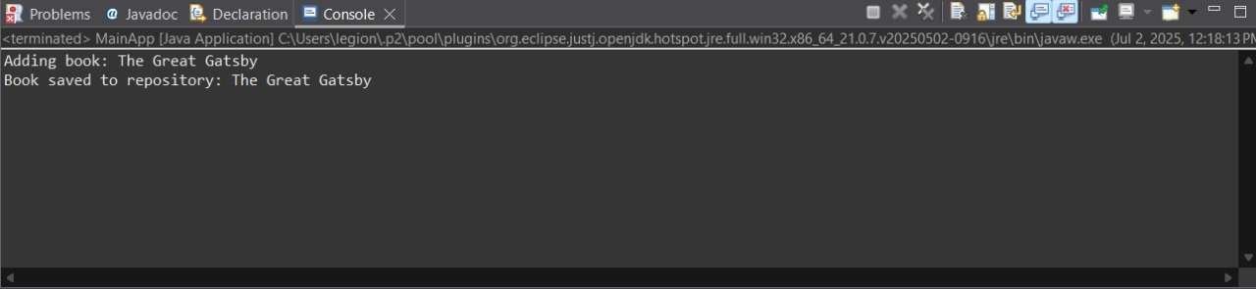

**Exercise 2: Implementing Dependency Injection**

**Scenario:**

In the library management application, you need to manage the dependencies between the BookService and BookRepository classes using Spring's IoC and DI.

**Code:**

**Mainapp.java:**

package com.library.main;

import org.springframework.context.ApplicationContext;

import org.springframework.context.support.ClassPathXmlApplicationContext;

import com.library.service.BookService;

public class MainApp {

public static void main(String[] args) {

ApplicationContext context = new ClassPathXmlApplicationContext("applicationContext.xml");

BookService service = (BookService) context.getBean("bookService");

service.addBook("The Great Gatsby");

}

}

**BookRepository.java:**

package com.library.repository;

public class BookRepository {

public void save(String bookName) {

System.***out***.println("Book saved to repository: " + bookName);

}

}

**BookService.java:**

package com.library.service;

import com.library.repository.BookRepository;

public class BookService {

private BookRepository bookRepository;

// SETTER for Dependency Injection

public void setBookRepository(BookRepository bookRepository) {

this.bookRepository = bookRepository;

}

public void addBook(String bookName) {

System.***out***.println("Adding book: " + bookName);

bookRepository.save(bookName);

}

}

**applicationContext.xml:**<?xml version=*"1.0"* encoding=*"UTF-8"*?>

<beans xmlns=*"http://www.springframework.org/schema/beans"*

xmlns:xsi=*"http://www.w3.org/2001/XMLSchema-instance"*

xsi:schemaLocation=*"*

*http://www.springframework.org/schema/beans*

*https://www.springframework.org/schema/beans/spring-beans.xsd"*>

<bean id=*"bookRepository"* class=*"com.library.repository.BookRepository"*/>

<bean id=*"bookService"* class=*"com.library.service.BookService"*>

<property name=*"bookRepository"* ref=*"bookRepository"*/>

</bean>

</beans>

**Output:**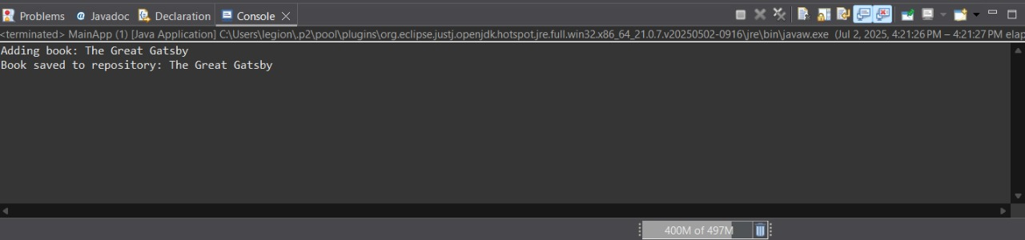

**Exercise 4: Creating and Configuring a Maven Project**

**Scenario:**

You need to set up a new Maven project for the library management application and add Spring dependencies.

**Code:  
  
Mainapp.java:**

package com.library.main;

import com.library.service.BookService;

import org.springframework.context.ApplicationContext;

import org.springframework.context.support.ClassPathXmlApplicationContext;

public class MainApp {

public static void main(String[] args) {

ApplicationContext context = new ClassPathXmlApplicationContext("applicationContext.xml");

BookService service = (BookService) context.getBean("bookService");

service.addBook("The Great Gatsby");

}

}

**BookRepository.java:**

package com.library.repository;

public class BookRepository {

public void save(String book) {

System.***out***.println("Book saved to repository: " + book);

}

}

**BookService.java:**

package com.library.service;

import com.library.repository.BookRepository;

public class BookService {

private BookRepository bookRepository;

// Setter for Dependency Injection

public void setBookRepository(BookRepository bookRepository) {

this.bookRepository = bookRepository;

}

public void addBook(String book) {

System.***out***.println("Adding book: " + book);

bookRepository.save(book);

}

}

**applicationContext.xml:**<?xml version=*"1.0"* encoding=*"UTF-8"*?>

<beans xmlns=*"http://www.springframework.org/schema/beans"*

xmlns:xsi=*"http://www.w3.org/2001/XMLSchema-instance"*

xsi:schemaLocation=*"*

*http://www.springframework.org/schema/beans*

*https://www.springframework.org/schema/beans/spring-beans.xsd"*>

<bean id=*"bookRepository"* class=*"com.library.repository.BookRepository"*/>

<bean id=*"bookService"* class=*"com.library.service.BookService"*>

<property name=*"bookRepository"* ref=*"bookRepository"*/>

</bean>

</beans>

**Output:**

